Enjoy your learning!

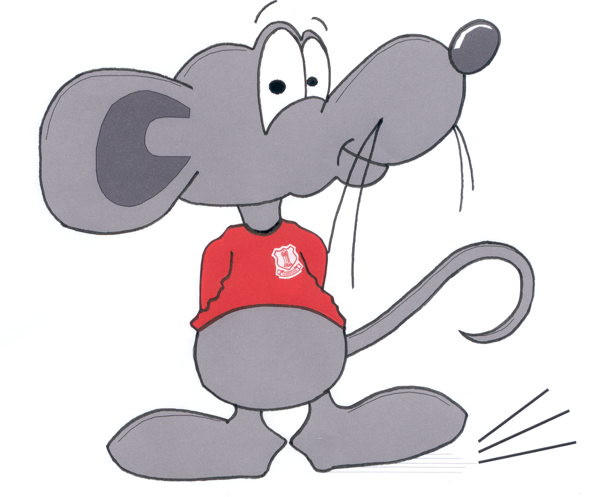
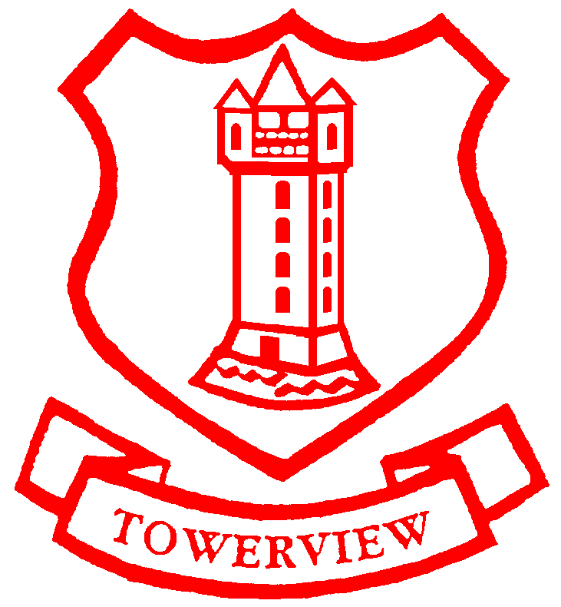
Towerview Primary School Term 1 Learning Plan P2

The World Around Us
- Town and Country- our local environment. Similarities and differences between town and country. Awareness of landmarks in the town of Bangor
- Into the Woods- identification of indigenous leaves and trees. Seasonal changes. Woodland animals and habitats. The country code and sustainability

Language and Literacy
- Participate in games and activities relating to phonological awareness, including an introduction to the Read Write Inc. Phonics Scheme- using two letters one sound to generate new words by changing letters.
- Engage in modelled, shared, and guided writing, leading to an awareness of simple punctuation and spelling. Encourage some independence, focusing on recount and narrative writing. Introduce upper case letters, letter names and letter formation.
- Participate in reading activities- discussing the text, using a range of cues to decode unfamiliar words, sequencing stories, developing an awareness of self-checking and correcting mistakes independently
- Engage in task appropriate talking and listening activities encouraging skills of recall/description/explanation/instruction/prediction/ sequencing/ asking and answering questions using puppets. Preston the Predicting Wizard, Queenie the Questioning Policewoman, Saul the Summarising Snapdragon, Clarence the Clarifying Clown.

Numeracy
- Order numerals and sets within 20 using Numicon
- Make sensible estimates of up to 10 objects
- Begin to investigate components of number 10
- Count forwards and backwards up to 30. Count on and back from different starts
- Use of number line and blank number array to 20 (place a counter on the number)
- Comparison of size of 2 or 3 objects- long, longer, longest, tall, taller, tallest etc.
- Become aware of and use vocabulary associated with ‘time’ and recognize the
passing of time and how we measure it (second/ minute/ hour)
- Investigate and talk about properties of 2D shape
- Sort and resort apparatus for up to 3 criteria
- Engage in oral problem-solving activities and mental maths
- Investigate and talk about pattern in the environment. Copy, continue and create patterns

Creative and Expressive Studies
- Respond to music and radio broadcast “Let’s Move” (movement and dance)
- Creating sounds with percussion instruments
- Songs, poems, and stories related to topics
- Investigate different media & techniques to produce artwork
- Mime and role play activities related to topics
- Use different media (painting, printing, collage, junk art)
- Design Christmas cards and decorations

ICT

Program bee bots to move forwards, backwards and turn
- Literacy and maths games on computers and interactive whiteboard to support learning
- Use MS paint to create pictures of where we live

Primary Language French
- Continue to learn about the country and its culture
- Respond to greetings using big books, puppets, games, songs, and CD to extend vocabulary

Personal Skills and Capabilities
- TAPS programme-learning about how we need to be thankful.
- Daily emotional check in.
- Working co-operatively in a group - turn taking and sharing.
- Learning how to come into school independently and organising their belongings without parental guidance.
- Hygiene-washing hands before eating food.
- Managing information, being creative, thinking skills, problem solving and decision making.
Learning Experiences
- Supportive learning environment with positive reinforcement.
- Independent and small group practical tasks to challenge and engage.
- Opportunities for problem solving and investigative learning.
- Relevant, enjoyable, and enquiry-based learning.
- Opportunities for pupils to reflect on tasks.
- Playful and engaging tasks indoor and outdoor

R.E. Learning about God’s world and how to care for it

