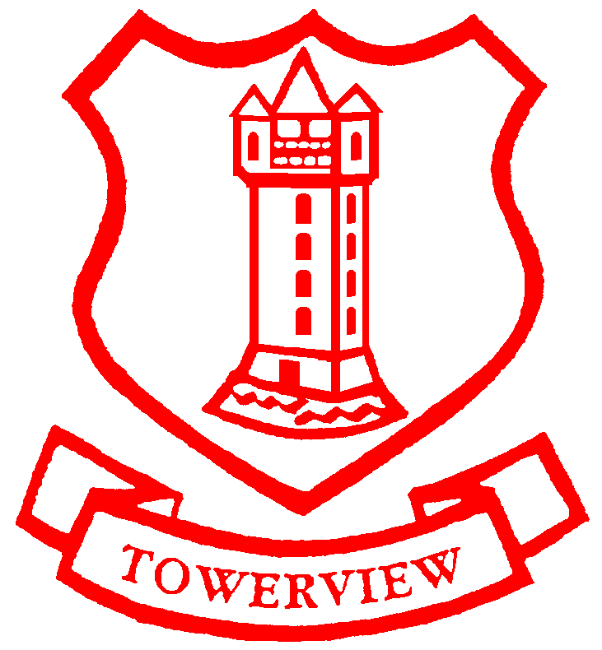
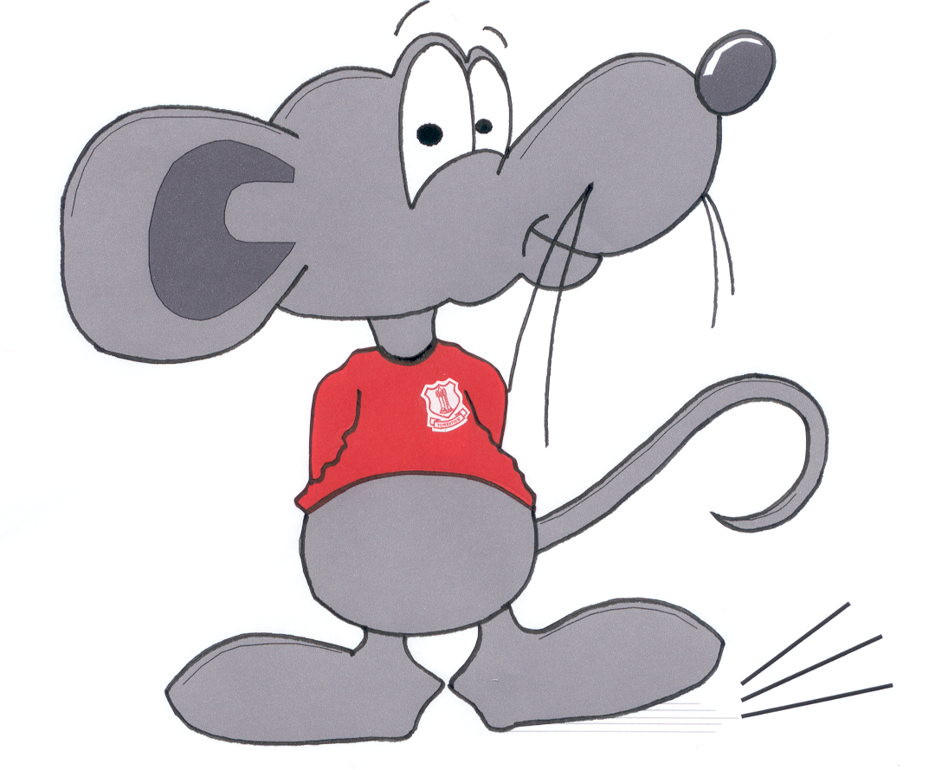
Towerview Primary School
Term 2 Learning Plan
P2
Language and Literacy  - Participate in games and activities relating to phonological awareness including vowel and consonant digraphs such as oo, ar, oy, ow, or and igh. Generating new words.  - Engage in modelled, shared and independent writing in differing genres  (to include, narrative and instructional text) self-monitoring  and correcting  - Increase awareness of punctuation when reading and writing  - Participate in reading activities:- discussing text (offering explanations,  predictions and alternative endings). Use a range of cues to decode  unfamiliar words, self-correct and improve expressive reading.  - Engage in task appropriate ‘talking and listening’ activities including ‘think/pair/share’  - , ‘hot seating’ and talking to different audiences for different purposes. |  |  | Mathematics and Numeracy  - Order numerals and sets within 20 using Numicon  - Make sensible estimates of up to 15 objects  - Revise components of numbers (2➔10)  - Count in 2s and 10s (see pattern on a 100 square)  - Recognise odd and even numbers within 100  - Use of number line and blank number array to 20 (emphasis on teen  numbers) Understand that teen numbers are 10 + another number  - Become aware of and use vocabulary associated with ‘time’ and recognise  the passing of time and how we measure it (second/ minute/ hour)  - Recognise o’clock times on both analogue & digital clocks  - Compare 2 or more objects of differing weight  - Investigate and talk about properties of 3D shape  - Engage in oral problem solving activities and in ICT games
The World Around Us  - Whatever the Weather – Investigate seasonal changes, temperature, precipitation, wind speed and direction. Watch, discuss and improvise weather forecasts. Monitor local weather and investigate extreme weather. Discuss the Chinese New Year.  - To infinity and beyond – Our place in the solar system. Features of Earth and other planets. Space travel. Design and make space buggies using construction toys. Role play in a space rocket and at ‘ground control’. |  |  | The Arts and Physical Education  - Respond to music (movement and dance)  - Fundamental Movement Skills (body management skills/ object control skills)  - Simple composing and performing, listening and responding to music  - Songs and poems related to topics  - Investigate different media and techniques to produce art work  - Observe and discuss the work of famous artists  - Participate in role play and drama games
ICT  - IWB games and activities to support learning  - Independently log on / off / print and navigate to use aps with support  - Refine mouse control through various drawing and manipulation programs  - Word processing using various programs | R.E.  - Continue to learn about Old and New Testament stories  - The Easter Story  - Participate in Assemblies & respond to talks from visiting clergy  - TAPS programme |  |  | Primary Languages – French  - Continue to learn about the country and customs.  - Revise and extend vocabulary for numbers, colours, body parts, greetings, weather and animals.
Personal Skills and Capabilities  - TAPS programme – learning about the themes of honesty, self- control and fairness.  - Self-management – being aware of personal strengths and setting personal targets. Managing behavior in a range of situations.  - Thinking skills – making connections between learning in different contexts. |  | Learning Experiences  - Supportive learning environment with positive reinforcement  - Independent and small group practical tasks to challenge and engage  - Opportunities for problem solving and investigative learning  - Relevant, enjoyable and enquiry based learning  - Opportunities for pupils to reflect on tasks.

